Design Document

This software allows a user to input an xml file to load a scene containing a variety of objects and cameras and use them to play a game in which a robot picks up collectables to reach the end win goal.

Game Objects

Game Objects are all of the visible objects in the game. These can be robots, collectables or just normal objects. The way these objects are structured is by having a game object class which keeps hold of the objects models and main data such as positions. This is then used polymorphically by deriving the robot and collectable classes from the game object to get the more specific behaviours that the robot and the collectables can use individually.

The way I constructed the modelling of the objects themselves has been done by giving the ability to use multiple models on one object each with their own positional data so the user could for instance replace the arms of a robot and position the pieces at different parts of the body by just changing the corresponding models data whilst keeping it as a game object with multiple pieces.

Cameras

Cameras are also loaded from files by taking a position look at point and an up vector. The camera can be set to follow the player automatically by using the letter p.

The map

To the left is the map design of the scene given in the software. The red circles indicate camera locations, the white circles indicate lights, the yellow Ts are Screw collectables and the robot face is the robot’s starting position.

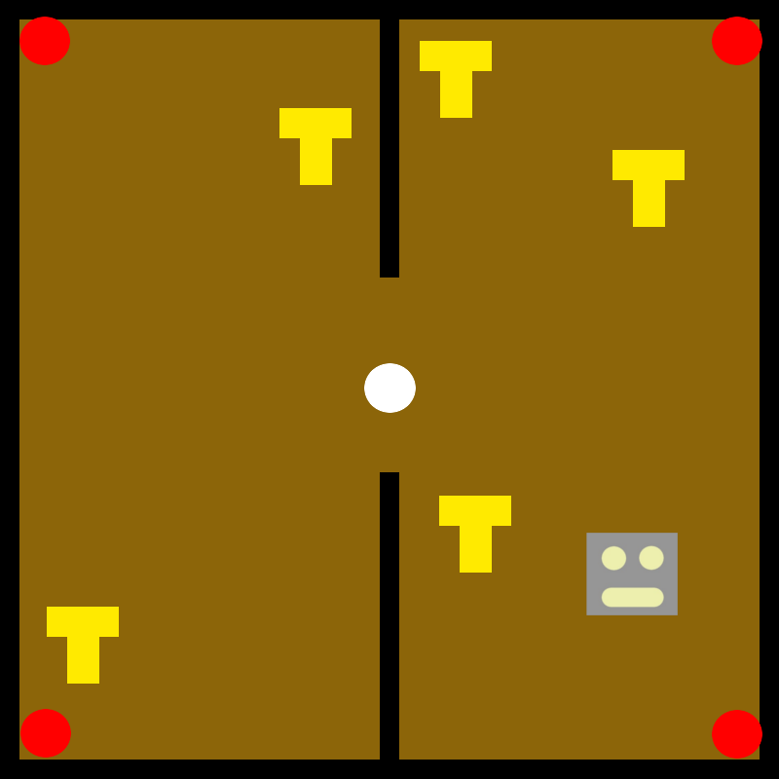

Controls

|  |  |
| --- | --- |
| Left Click | Change to the next camera |
| Right Click | Change to the previous camera |
| W / Up Arrow | Move robot forwards |
| A / Left Arrow | Turn robot left |
| S / Down Arrow | Move robot backwards |
| D / Right Arrow | Turn robot right |
| Enter / Return | Moves between menus (When prompted) |

Class Diagram

Below is the class diagram of the classes I used in the software.



# References

*http://www.textures.com/category/wood/427*. (2017, January 22). Retrieved from FreeLargeImages.com: http://www.freelargeimages.com/wood-texture-1462/

mibmob. (2017, January 22). *Drawer2*. Retrieved from TF3DM: http://tf3dm.com/3d-model/drawer2-47553.html

Minareadjin. (2016, January 23). Retrieved from deviant art: http://www.deviantart.com/art/Assisi-Wall-Texture-7-Tile-V-H-1024x1024-586235425

omar31. (2017, January 22). *Wooden Table*. Retrieved from TF3DM: http://tf3dm.com/3d-model/wooden-table-49763.html

*Wood Background*. (2016, October 18). Retrieved from pinterest: https://uk.pinterest.com/explore/wood-background/